Dear Friends of Dunwoody High School Volleyball:

The Dunwoody Wildcats Girls’ Volleyball team is now accepting community/sports partnerships for the 2017-2018 school year. We appreciate your consideration in becoming a valued sponsor of Dunwoody Volleyball at one of the following levels:

Sponsorship Level | Recognition & Benefits
Friends & Family - $100 | - Name on DHS Volleyball website - http://dunwoodyvolleyball.weebly.com/
Bronze - $100 | - Company name & logo on DHS Volleyball website  - One sponsor tweet from Dunwoody Volleyball Twitter account
Silver - $250 | - Bronze PLUS  - Sponsor appreciation plaque with team photo  - Company logo on Dunwoody Volleyball t-shirts  - One email blast promotion to the Dunwoody Volleyball distribution list
Gold - $500 | - Silver PLUS  - Company logo on 16’ varsity team photo and banner in the gym  - Sponsor night for one DHS home match
Platinum - $1,000 | - Gold PLUS  - One additional email blast promotion to the Dunwoody Volleyball distribution list  - Larger company logo on 16’ varsity team photo and banner in the gym  - Preferred placement on website and on multiple pages

ALL SPONSOR DONATIONS ARE TAX DEDUCTIBLE
ALL SPONSORS are included on the gymnasium ‘THANK YOU’ banner
ALL SPONSORS are highlighted on the DHS VOLLEYBALL WEBSITE
ALL SPONSORS are included on the banner for the team’s annual appearance in the Dunwoody 4th of July Parade.

Dunwoody High School serves over 1,800 students and competes in GHSA Class 6A. Volleyball matches are held in the Dunwoody High gym and at many Metro-Atlanta high schools.
Players, parents and fans alike proudly wear their team t-shirts throughout the calendar year.

For questions contact Joe Seegars at 678-488-0803

Thank you for your support of Dunwoody High School Volleyball
2013-2016 – 3 State Championship Final Fours and 1 Elite Eight

2017 Sponsorship
Dunwoody High School Girls Volleyball

STEP 1

Company Name: _____________________________________________________________
^{as you wish to be acknowledged}
Company Contact Name: ______________________________________________________

Contact Phone Numbers: ______________________________________________________

Postal Address: ______________________________________________________________

E-mail Address: ______________________________________________________________

Referred by: ________________________________________________________________

STEP 2: Make your check payable to Dunwoody Volleyball Inc. (Note Dunwoody Volleyball Inc. is a 501(c)(3) tax-exempt entity. All donations are tax-deductible.)

STEP 3: Mail this form and your check to: Dee Callihan
1006 Weldstone Ct.
Atlanta, GA 30350

STEP 4: Please send logo electronically to: joeseegars@gmail.com.

Your logo and url will be posted on our web site - http://dunwoodyvolleyball.weebly.com/

For questions contact Joe Seegars at 678-488-0803

Your sponsorship helps fund coaches, equipment, tournament fees and other team operations.

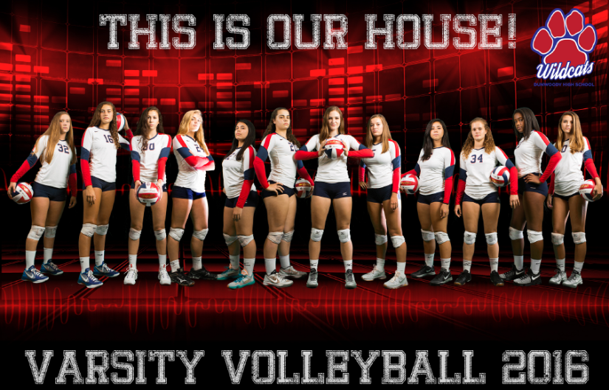
Thank you for supporting Dunwoody High School Personal Responsibility In Developing Excellence

